- Pick any one popular Indian food delivery website (like Zomato or Swiggy), use a free backlink checker tool (such as Ahrefs Backlink Checker or Ubersuggest), and list 5 domains that link to it along with their domain ratings.
No. | Referring Domain | Domain Rating (DR)
1 | google.com | 99
2 | facebook.com | 100
3 | instagram.com | 99
4 | linkedin.com | 98
5 | youtube.com | 100

- Choose a well-known e-commerce site (like Flipkart or Myntra), and identify 3 backlinks that look suspicious or low-quality using a backlink analysis tool. Explain why you think each one could be toxic.<br><br><em><strong>Hint:</strong> Look for backlinks from unrelated, spammy, or foreign-language sites with low authority.</em>
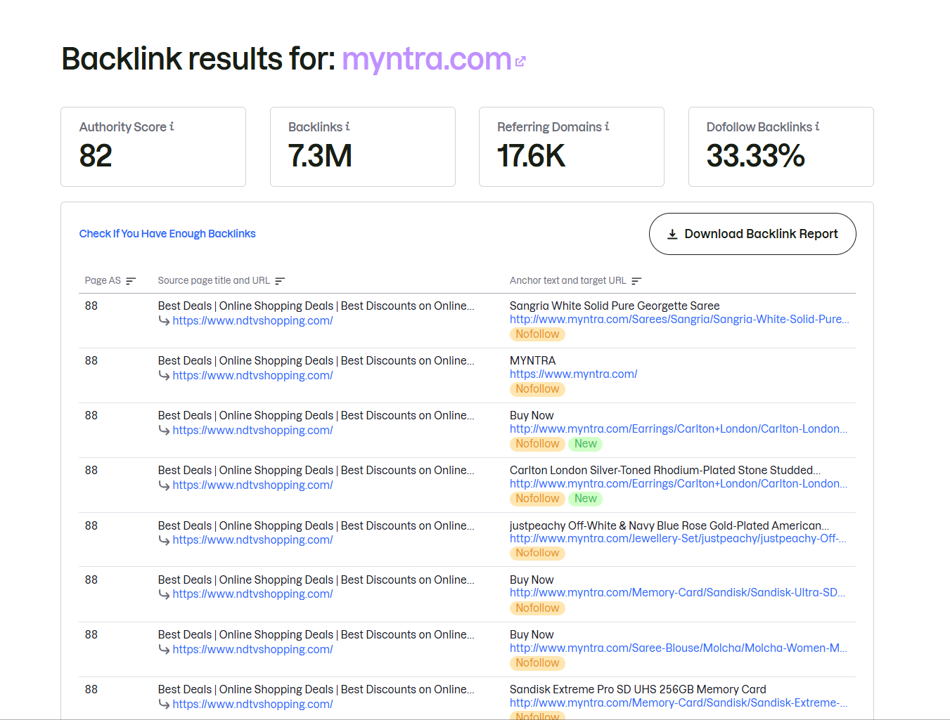
- Use the Google Disavow Tool (or its simulation in a free SEO tool) to create a disavow file for the 2 most toxic backlinks you found for your chosen site. Write the exact text you would submit in the disavow file.

Disavow toxic backlinks for Myntra

The two most suspicious backlinks shown are from ndtvshopping.com
Domain-level disavow covers both backlinks
domain:ndtvshopping.com
- Pick two competing apps (for example, BookMyShow vs Paytm Movies), and use a backlink gap analysis tool (like SEMrush Backlink Gap or Ubersuggest) to find 3 domains that link to one but not the other. List these domains and suggest why they might link to only one competitor.
Domain | Links to | Why it may link only to this competitor
indiatimes.com | BookMyShow | IndiaTimes publishes entertainment and movie-related content, so BookMyShow is a natural source for movie/show information and ticket links.
filmibeat.com | BookMyShow | Filmibeat focuses heavily on movies, reviews and entertainment. BookMyShow has strong relevance for movie ticket booking, making it useful for its readers.
indianexpress.com | BookMyShow | Indian Express covers movie releases and entertainment news; BookMyShow can provide a direct ticket-booking resource for readers.
- Use ChatGPT to generate a step-by-step checklist for cleaning up a website's backlink profile, including identifying, evaluating, and removing toxic links. Paste the checklist and mention one thing you learned that you didn’t know before.<br><br><em><strong>Hint:</strong> Try prompts like 'Give me a detailed checklist for backlink cleanup for a website.'</em>

Backlink Cleanup
- Find backlinks using Google Search Console, SEMrush, or Ubersuggest.
- Check which links are spammy or irrelevant.
- Identify toxic backlinks.
- Ask website owners to remove them.
- Create a disavow file for links that cannot be removed.
- Submit the file to Google.
- Monitor backlinks regularly.
- Build quality backlinks.

